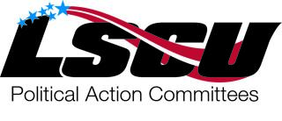
MULLIGANS

$5.00 EACH OR FIVE FOR 20.00

A portion of the purchase price will be contributed to the League of Southeastern Credit Unions Federal Political Action Committee. Contributions to LSCU Fed PAC are not considered charitable or business expenses for income tax purposes. Contributions are voluntary and there shall be no reprisal for those who decide not to contribute
